|  |  |  |  |
| --- | --- | --- | --- |
| D:\Rinat\Rinat\доки\журнал\статьи\logo.jpg | INFLUENCE OF the GLASS FIBER CONTENT ON THE PROPERTIES OF PRINTED PRODUCTS BASED ON POLYPHENYLENE SULFIDE | | |
| Cite this: *INEOS OPEN*,  **2025**, *8 (1–3)*, 13–15  DOI: 10.32931/io2502a  *Received 9 September 2024,*  *Accepted 13 November 2024*  http://ineosopen.org | | I. S. Larionov,\**a,b* D. A. Balkaev,*a* K. S. Zimin,*a,b* N. A. Androsov,*b* L. M. Amirova,*b* and I. S. Antipin*a* | |
| a Kazan Federal University, ul. Kremlevskaya 18, Kazan, Tatarstan, 420008 Russia  b Kazan National Research Technical University named after A. N. Tupolev–KAI, ul. K. Marksa 10, Kazan, Tatarstan, 420111 Russia | |
| Abstract  A mode of filament extrusion for 3D printing from high-temperature Russian thermoplastic polyphenylene sulfide and the glass-filled composites based on it bearing 10, 20, or 30 wt % of fiber was developed. The effect of the content of short glass fiber in the composites on the mechanical and thermal properties of the printed products was determined. | | | C:\Users\dinar\OneDrive\Рабочий стол\Статья Печать ПФС\Графическая аннотация.png |
| **Key words:** polyphenylene sulfide, fiberglass, fused deposition modeling, composites. | | | |

**Introduction**

Polyphenylene sulfide (PPS) is a superstructural thermoplastic which can be widely used in various industries. Its application in fused deposition modeling (FDM printing) allows for the production of chemically resistant, durable and heat-resistant products of complex configurations, which can be recycled if necessary [1, 2].

Adding a fibrous filler to a polymer improves its physical and mechanical properties and heat resistance and reduces its shrinkage, which has a positive effect on the quality of printing and the dimensional stability of printed products [3, 4]. Moreover, due to its low cost, in some cases, fiberglass affords a reduction in the cost of final products.

PPS-based composites are most often reinforced with carbon and glass fibers [5–9] and are used to manufacture products using injection molding. The advantage of glass fiber is its high chemical resistance, due to which it is preferable for products operating in aggressive media. Another advantage is the low cost, which allows for reducing the cost of the material and final product.

The influence of dispersed fibrous filler on the properties of polymer-based products has been extensively studied, but only a limited number of reports are devoted to the PPS-based composites. Thus, Manjunath *et al.* [5] characterized the PPS-based composites filled with short glass fiber and determined the optimal filler concentration. The composite products were obtained by injection molding, and their properties were studied by conducting tensile, flexural, impact strength, heat deflection temperature (HDT) and dielectric strength tests. The authors came to the conclusion that the optimal glass fiber content in the PPS composite is 30%, while the tensile strength and tensile modulus grow with an increase in the glass fiber content to 40%, and the HDT reaches its highest values at a filler content of 20%.

In addition to the filler concentration, the properties of the composite are affected by the length of fibers. Li *et al*. [10] studied the effect of the length of glass fiber on the properties of PPS-based composites at the filler concentrations of 20 and 30%. The samples were obtained by injection molding, and their properties were determined by differential scanning calorimetry (DSC), tensile and flexural tests. The results of the study showed that the use of longer glass fibers leads to improved mechanical properties of the composite, but the peak crystallization temperature and crystallinity of such samples are significantly lower than those of the analogous composites reinforced with short glass fibers.

Due to the widespread use of FDM 3D printing in the production of industrial products, in recent years several studies were devoted to the properties of printed products made of PPS [1, 11, 12]. However, there are no reports on printing glass-filled composites based on PPS. The reason is that no filaments are produced industrially from such a material.

The characteristics of the composite products obtained by injection molding differ significantly from those of the printed products [13]. Therefore, the properties of the PPS composite products obtained by 3D printing require more in-depth studies. This is particularly interesting due to the appearance of Russian polyphenylene sulfide on the market, the composites of which have not been studied at all.

This work is devoted to the development of a manufacturing technology using the extrusion method of filament from Russian PPS and glass-filled composites based on it, as well as the characterization of the products obtained by 3D printing.

Materials and methods

To produce the filament, linear polyphenylene sulfide powder with a melt flow rate (MFR) of 436 g/10 min (at 316 °С, 5 kg) obtained from OOO "NTTs Ahmadulliny" was used, which is not inferior in its characteristics to the foreign analogs [14]. Chopped glass fiber EC-13-4.5 mm-A42 produced by OOO "P-D Tatneft-Alabuga Steklovolokno" was used as a filler.

The filament was obtained on a Scientific LTE 16–40 twin-screw extruder with water strand cooling. Samples for mechanical and thermal tests were printed on a Picaso Designer XL PRO S2 3D printer with the following parameters: nozzle diameter 0.8 mm, layer thickness 0.4 mm, printing speed 60 mm/min. The crystallinity degree of the printed samples was assessed using differential scanning calorimetry on a DSC 214 Polyma NETZSCH device at a speed of 10 °C/min. The degree of crystallinity was calculated based on the enthalpy of melting of the samples, relating them to the value of the melting enthalpy of 100% crystalline PPS (76.5 J/g). The tensile tests of the samples obtained were carried out on a UTS-111 (Testsystems) universal electromechanical testing machine with wedge-shaped grips and a deformation rate of 5 mm/min according to ISO 527. The values of HDT for the resulting samples were determined on a SMARTEST VHDT 1113 device with a heating rate of 2 °C/min and a created stress of 1.8 MPa according to ISO 75-1. Unnotched Izod impact tests were carried out on a TSMK-50 (Testsystems) pendulum impact machine with a pendulum energy of 7.5 J according to ISO 180.

Results and discussion

In this work, a filament extrusion mode for 3D printing from high-temperature thermoplastic PPS and glass-filled composites based on it was developed.

The original PPS turned out to be unsuitable for filament production, since its melt viscosity was too low (MFR 436 g/10 min), which led to unevenness in the size of the drawn thread and frequent breaks. In this regard, the first stage of the developed technology was to increase the viscosity of the melt to the MFR level of 20–90 g/10 min. To reduce MFR, the sample powder was subjected to thermooxidative cross-linking [15]. The powder was preliminarily kept at 245–270 °C for 60 min in the air. The MFR of the powder after heat treatment was 25–40 g/10 min, due to which it became applicable for the filament production.

Four filaments with a glass fiber content of 0, 10, 20, and 30% were obtained on a twin-screw extruder. The temperature of the extruder cylinder varied within 290–325 °С. For better fiber distribution, the material was extruded twice, and the filament was drawn only during the second extrusion.

To determine the average length of the glass fiber in the resulting filament, the samples were burned in a muffle furnace at 550 °C. Using an optical microscope, based on 100 measurements of the lengths of the fibers remaining after burning, it was found that the average fiber length was about 200 µm.

Tensile and impact strength testing were selected as the research methods, as they are the standard methods for determining the mechanical characteristics of the material and are used in most articles. Due to the fact that PPS-based products are often used at elevated temperatures, the HDT test method was also used, which is the standard method for determining the heat resistance of polymeric materials.

The filaments obtained were used to print samples of the form B1 bar and A1 tensile specimen, the dimensions of which were taken from ISO 20753. In order for the samples to be in the same conditions, the maximum crystallinity degree was achieved for each sample. For this purpose, the samples were crystallized in an oven at a temperature of 180 °C for 2 h. The DSC analysis showed that the furnace-annealed sample lacked a cold crystallization peak, unlike the initial sample just taken after printing. Both samples also had the same enthalpies of melting and crystallization from the melt, indicating that the maximum degree of crystallinity had been achieved.

The heat deflection temperature tests (Fig. 1) revealed a significant increase in heat resistance which occurs already with the addition of 10 wt % of glass fiber, when HDT increased from 117.6 to 184 °С, with a glass fiber content of 0% and 10%, respectively. A further increase in the filler concentration to 20% leads only to a slight increase of HDT to 189 °С. The addition of 30% of glass fiber also afforded a slight increase in the HDT value, amounting to 197.5 °С.

According to the results of the tensile tests, the elastic modulus increases smoothly with increasing fiberglass content (Fig. 2). For the unfilled samples, its value composes 3430 MPa and increases to 4420 MPa with the addition of 10% of the fibrous filler. The elastic modulus for the samples with 20% filling was 6240 MPa, and that for the sample with 30% filling was 7200 MPa, which is more than 2 times higher than the result of unfilled samples. Another situation occurs when considering the tensile strength (Fig. 3), when the strength of the material increases with an increase in the filler concentration to 20%, growing from 29.3 MPa to 62.4 MPa, after which it reaches a plateau, showing no growth at 30% of the fiberglass (61.1 MPa).

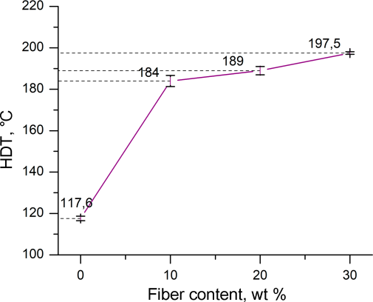

**Figure 1.** Effect of the filler mass fraction on the value of HDT.

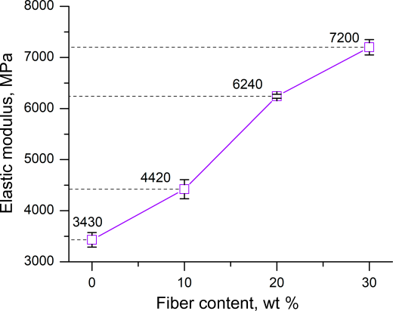

**Figure 2.** Effect of the filler mass fraction on the elastic modulus.

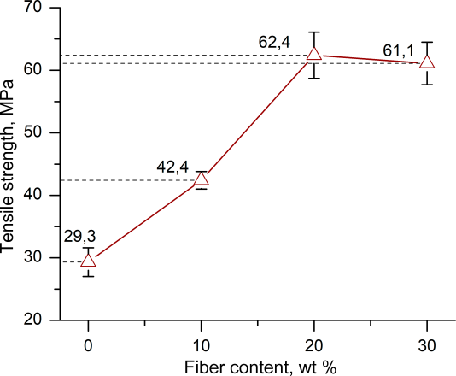

**Figure 3.** Effect of the filler mass fraction on the tensile strength.

Similar results were achieved when determining the impact strength of the material (Fig. 4). In the absence of the filler, the impact strength of the material was the lowest one, amounting to 10 kJ/m2. The addition of 10% of the filler slightly strengthened the samples, providing the impact strength of 10.9 kJ/m2. With a further increase in the filler concentration to 20%, there was a sharp increase in the impact strength to 16.4 kJ/m2, after which, with the addition of 30% of glass fiber, the impact strength remained almost unchanged, amounting to 17.1 kJ/m2.

The reason for the lack of significant improvement in the mechanical characteristics at 30% filling may be the increased fragility of the material and the inevitable defects of FDM printing (gaps between plastic lines), which do not allow the material's characteristics to be fully realized during 3D printing. At the same time, the elastic modulus continues to grow at the considered concentration due to the fact that it is determined in the region of initial deformations of the sample, where the effect of brittleness is minimal, and the positive effects of increased fiber content are fully manifested. Furthermore, due to the specific technique of HDT tests, their results are influenced to a greater extent by the elastic modulus of the samples rather than their brittleness, which explains the smooth growth of the HDT of the filled samples.

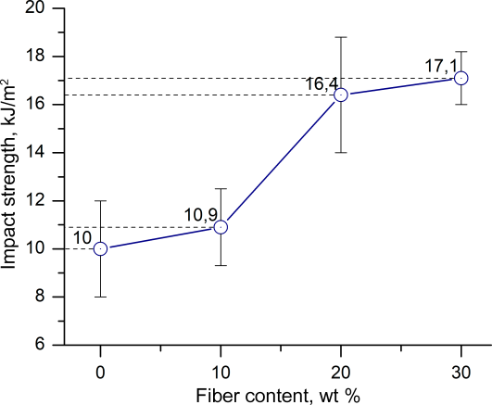

**Figure 4.** Effect of the filler mass fraction on the Izod impact strength.

**Conclusions**

Thus, a technology for obtaining filament (including glass-filled) for 3D printing based on Russian PPS was developed for the first time and the products printed using this technology were characterized. The properties of the products weredetermined at a filler concentration of 0/10/20/30%. It turned out that the preferred concentration of short glass fiber for the production of filament is 20 wt %, since it allows for achieving relatively high values of HDT, impact strength, elastic modulus, and tensile strength. At the same time, the material retains sufficiently high fluidity for 3D printing and simplifies the filament manufacturing process owing to the reduced brittleness compared to the material with 30% of glass fiber.

Acknowledgements

This work was supported by the Russian Science Foundation (project no. 24-63-00026).

Corresponding author

* E-mail: larionov_igor1999@mail.ru (I. S. Larionov).

References

1. P. Geng, J. Zhao, W. Wu, Y. Wang, B. Wang, S. Wang, G. Li, *Polymers*, **2018**, *10*, 875. DOI: 10.3390/polym10080875

2. L. Zhao, Y. Yu, H. Huang, X. Yin, J. Peng, J. Sun, L. Huang, Y. Tang, L. Wang, *Composites*, *Part B*, **2019**, *174*, 106790. DOI: 10.1016/j.compositesb.2019.05.001

3. M. Parker, A. Inthavong, E. Law, S. Waddell, N. Ezeokeke, R. Matsuzaki, D. Arola, *Addit. Manuf.*, **2022**, *54*, 102763. DOI: 10.1016/j.addma.2022.102763

4. G. Sodeifian, S. Ghaseminejad, A. A. Yousefi, *Results Phys.*, **2019**, *12*, 205–222. DOI: 10.1016/j.rinp.2018.11.065

5. A. Manjunath, H. Manjushree, K. C. Nagaraja, Pranesh K. G., *Mater. Today: Proc.*, **2022**, *62*, 5439–5443. DOI: 10.1016/j.matpr.2022.04.083

6. K. Stoeffler, S. Andjelic, N. Legros, J. Roberge, S. B. Schougaard, *Compos. Sci. Technol.*, **2013**, *84*, 65–71. DOI: 10.1016/j.compscitech.2013.05.005

7. Y. Seki, E. Kizilkan, B. M. Leşkeri, M. Sarikanat, L. Altay, A. Isbilir, *ACS Omega*, **2022**, *7*, 45518–45526. DOI: 10.1021/acsomega.2c06152

8. P. Zuo, R. C. Benevides, M. A. Laribi, J. Fitoussi, M. Shirinbayan, F. Bakir, A. Tcharkhtchi, *Composites*, *Part B*, **2018**, *145*, 173–181. DOI: 10.1016/j.compositesb.2018.03.031

9. J. Deng, Y. Song, Z. Xu, Y. Nie, Z. Lan, *Polymers*, **2022**, *14,* 1275. DOI: 10.3390/polym14071275

10. N. Li, X. Li, A. Yao, Z. Guo, X. Liu, H. Li, Y. Wang, J. Liang, Z. Chen, *J. Reinf. Plast. Compos.*, **2024**. DOI: 10.1177/07316844241232960

11. P. Geng, J. Zhao, Z. Gao, W. Wu, W. Ye, G. Li, H. Qu, *3D Print. Addit. Manuf.*, **2021**, *8*, 33–41. DOI: 10.1089/3dp.2020.0052

12. A. El Magri, S. Vaudreuil, K. El Mabrouk, M. Ebn Touhami, *IOP Conf. Ser.: Mater. Sci. Eng.*, **2020**, *783*, 012001. DOI: 10.1088/1757-899X/783/1/012001

13. M. Dawoud, I. Taha, S. J. Ebeid, *J. Manuf. Processes*, **2016**, *21*, 39–45. DOI: 10.1016/j.jmapro.2015.11.002

14. V. V. Bitt, E. V. Kalugina, Y. G. Parshikov, A. V. Samoryadov, *Plast. Massy*, **2023**, *(11–12)*, 13–16. DOI: 10.35164/0554-2901-2022-11-12-13-16

15. P. Zuo, A. Tcharkhtchi, M. Shirinbayan, J. Fitoussi, F. Bakir, *Macromol. Mater. Eng.*, **2019**, *304*, 1800686. DOI: 10.1002/mame.201800686

|  |  |
| --- | --- |
| This article is licensed under a Creative Commons Attribution-NonCommercial 4.0 International License. | [D:\Rinat\Rinat\доки\журнал\cc-by-nc.png](https://creativecommons.org/licenses/by/4.0/) |